PROJECT AK5. PUPIL´S NAME:
REPORT
MY SIMPLE MACHINE IS A _____________ LEVER
ITS NAME IS______________________
IT IS MADE UP OF…….
OBJECT | NAME | MATERIAL | PROPERTIES

LIST OF RECYCLED MATERIALS

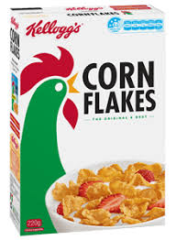  CEREAL BOX | SKEIN OF WOOL  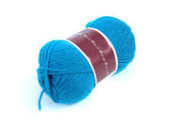 | CORCKS  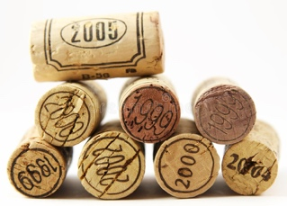
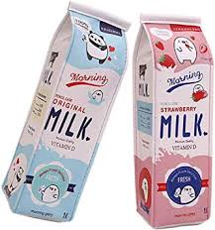  MILK CARTONS | PLASTIC BOTTLES  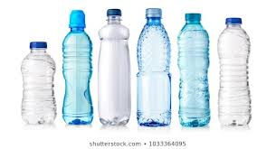 | 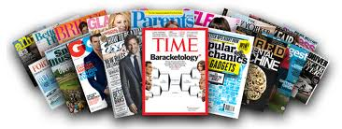  MAGAZINES AND NEWSPAPERS.
TOILET PAPER OR PAPER TOWER ROLLS  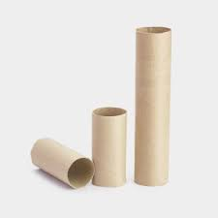 | EGG CARTON  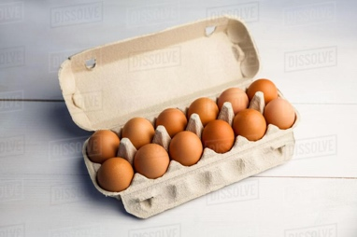 | FUNNEL ALUMINIUM FOIL  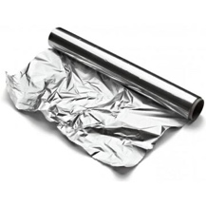  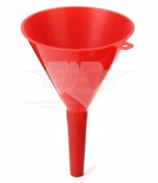
BOTTLE CAPS  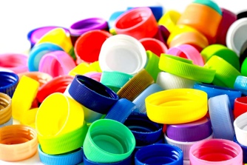 | CLOTHES PINS  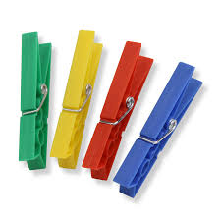 | CANS  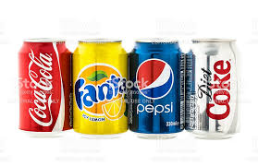
CLOTHES BUTTONS  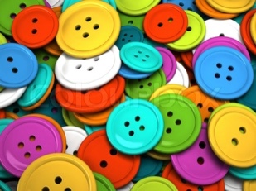 | 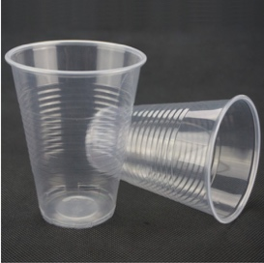  PLASTIC CUPS | SHOE BOX  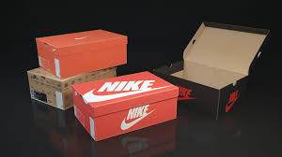
STRAWS ICECREAM  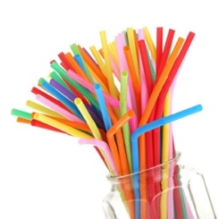  STICKS  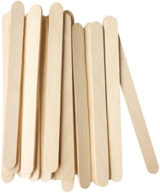 | PLASTIC YOGURT POTS  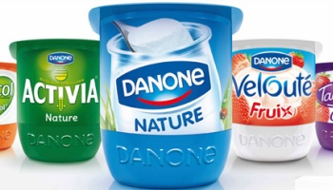 | 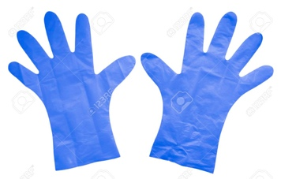  PLASTIC GLOVES

https://www.youtube.com/watch?v=zDR8tcGPA3s
https://www.youtube.com/watch?v=8GHRZabpsQE
A) REMEMBER THE PROPERTIES:
ELASTIC-RIGID
WATERPROOF- ABSORBENT
RESISTANT-FRAGILE
TRANSPARENT-OPAQUE- TRANSLUCID
HEAT CONDUCTOR-HEAT INSULATOR

B) REMEMBER THE MATERIALS:
PLASTIC
WOOD
LEATHER
COTTON
METAL (IRON OR STEEL)
GLASS
WOOL
CARDBOARD

