AK6 10/6/2020
https://www.youtube.com/watch?v=jMW_0Ro6b5c

1.- WATCH THE VIDEO AND CHANGE THE SENTENCES TO MAKE THEM TRUE
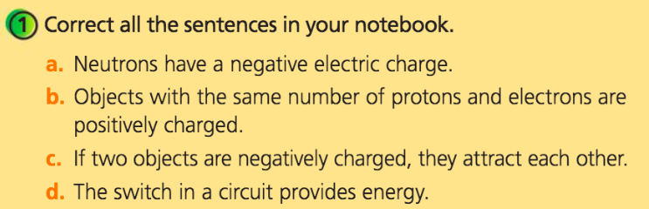

A.-

B.-

C.-

D.-

