AK4 19/4/2020

WRITE, AT LEAST, 3 PROPERTIES FOR EACH MATERIAL.
A) REMEMBER THE PROPERTIES:
ELASTIC-RIGID
WATERPROOF- ABSORBENT
RESISTANT-FRAGILE
TRANSPARENT-OPAQUE- TRANSLUCID
HEAT CONDUCTOR-HEAT INSULATOR

B) REMEMBER THE MATERIALS:
PLASTIC
WOOD
LEATHER
COTTON
METAL (IRON OR STEEL)
GLASS
WOOL
OBJECT | NAME | MATERIAL | PROPERTIES
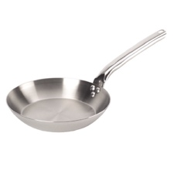 | PAN | METAL (STEEL) | RIGID  WATERPROOF  RESISTANT  OPAQUE  HEAT CONDUCTOR
