AK6 1/4/2020

READ THE TEXT CAREFULLY AND ANSWER THE QUESTIONS BELOW:

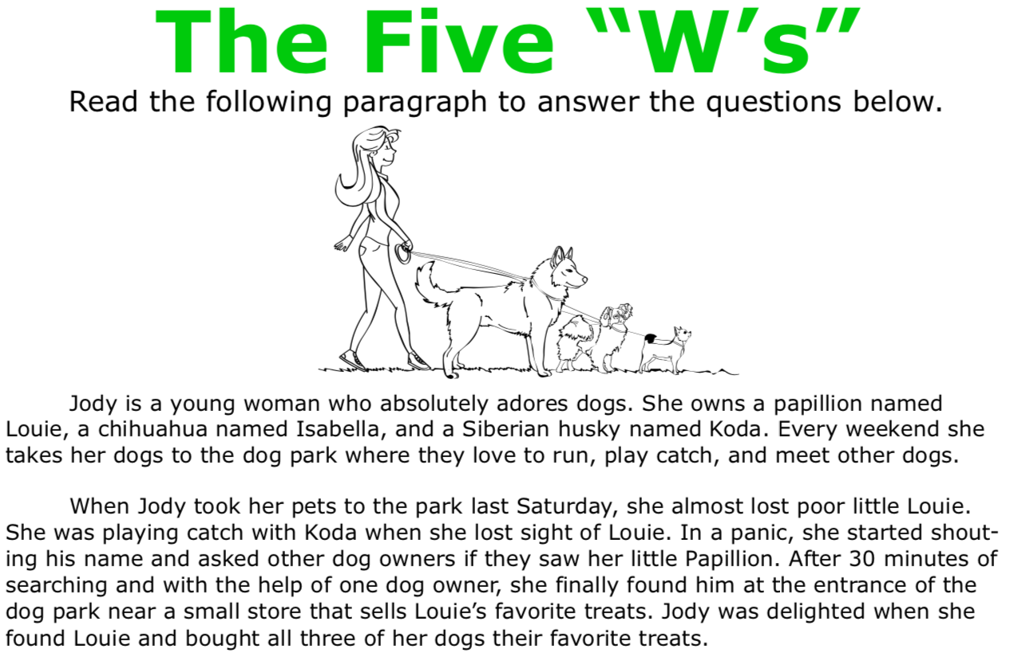

1.- WHO IS THE WOMAN IN THE HISTORY?

2.- WHAT THREE ACTIVITIES DO THE DOGS LOVE TO DO?

3.- WHEN DOES THE HISTORY TAKES PLACE?

4.- WHERE DOES THIS HISTORY TAKES PLACE?

5.- WHY IS JODY IN A PANIC?

