AK5 28/4/2020

HI, DO YOU REMEMBER ME? WHEN I GROW UP, A WANT TO BE A JEDI. BUT FIRST OF ALL, MY MASTER YODA WANTS ME TO KNOW ALL ABOUT MATTER AND ENERGY. I´M SURE YOU CAN HELP ME!

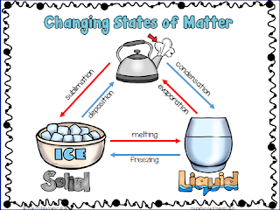

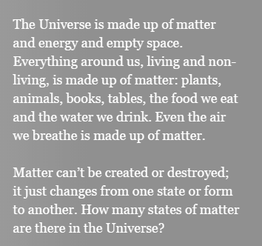

GAS

**1**

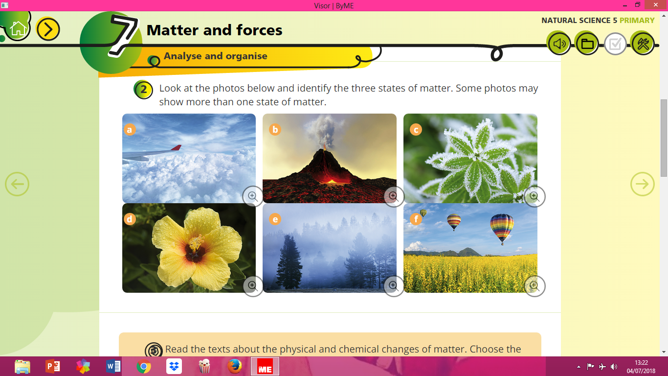

A.-

B.-

C.-

D.-

E.-

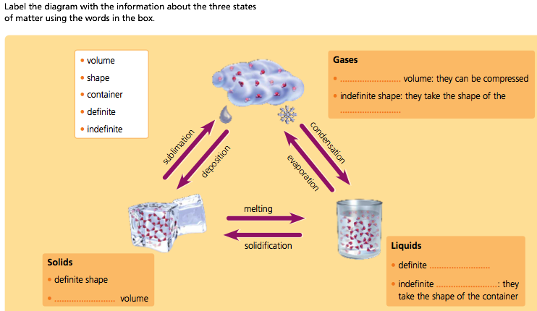F.-

**2**