**AK 5 21/4/2020**

[**https://www.youtube.com/watch?v=HQdiSMUZEDA**](https://www.youtube.com/watch?v=HQdiSMUZEDA)

**VERTEBRATES (MAMMALS, BIRDS, FISH, REPTILES and AMPHIBIANS)**

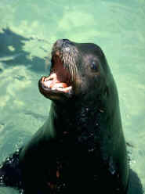

_______ are __________. So are ________, dogs, cats, horses, kangaroos, dolphins and _________.

What do all these animals have in common?

The answer is _______!  If an animal _________ milk when it is a baby and has ______ or ____ on its body, it belongs to the mammal class.

|  |  |  |  |
| --- | --- | --- | --- |
| hair | fur | mammals | people |
| whales | Seals | milk | drinks |

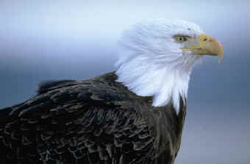________ are animals that have ___________ and that are born out of ___________________.

Some people think that what makes an animal a bird is its wings.  Bats have wings.  Flies have wings.  Bats and flies are not birds.  So what makes an animal a bird?

The answer is ______________!

Birds are the only animals that have ___________.  They help the bird to ______.

They also have two ____________ and a ____________.

|  |  |  |  |
| --- | --- | --- | --- |
| hard-shelled eggs | feathers | Birds | fly |
| legs | feathers | beak | feathers |

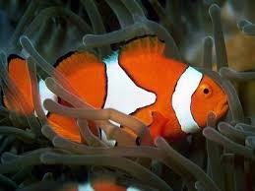___________ are vertebrates that live in _________ and have ________ to breath, __________ to swim and __________ on their body.  There are a lot of different fish.

|  |  |  |  |  |
| --- | --- | --- | --- | --- |
| Fish | gills | fins | water | scales |

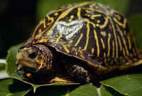

___________ are a class of animal with rough ______ skin.  They are ______________ and are born on ___________.

_________, ____________, ___________, ___________ and ___________all belong to the _________ class.

|  |  |  |  |  |
| --- | --- | --- | --- | --- |
| lizards | snakes | cold-blooded | land | scaly |
| Reptiles | crocodiles | alligators | turtles | reptile |

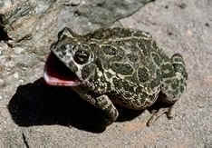

______ are born in the ____.  When they are born, they breathe with _____ like a fish.  But when they grow up, they develop ____ and can live on ______.

|  |  |  |  |  |
| --- | --- | --- | --- | --- |
| Amphibians | land | water | gills | lungs |