AK5 16/4/2020

INVERTEBRATES (INSECTS, CRUSTACEANS and ARACHNIDS)

Fill in the blanks with the words from the box:

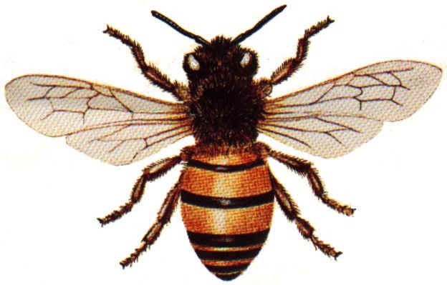
- Bees are _________ They have a thorax with six ______ and two ________, an __________, and a head with __________ and _________.
- Bees are ____________. They eat nectar from flowers.
- Bees have a thin _____________for protection.

wings | exoskeleton | eyes | legs
antennas | insects | abdomen | herbivores

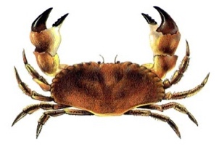
- Crabs are__________ .They have eight ________ and two ________. They have a ________ with ____________ and __________.
- Most crabs are ____________.
- Crabs have a thick ________________.
pincers | exoskeleton | eyes | legs
antennas | crustaceans | body | omnivores

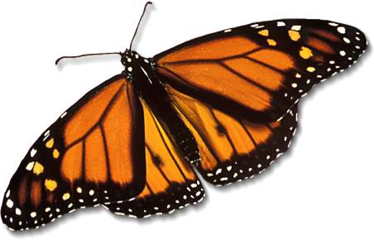
- Butterflies are ___________. They have a _______ with six legs and wings, an _________, and a _______ with ____________and two ___________.
- They have a thin ____________for protection.
- Butterflies are _______________.
head | exoskeleton | eyes | thorax
antennas | insects | abdomen | herbivores

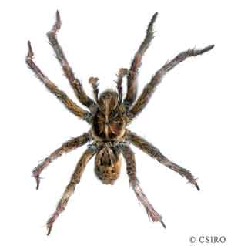
- Spiders are _________. They have eight _______. They have a ________, an __________, and a _________ with eyes and _____________.
- They are _____________. They eat insects.
- They have a thin _______________for protection.
head | exoskeleton | abdomen | legs
mouth | arachnids | thorax | carnivores

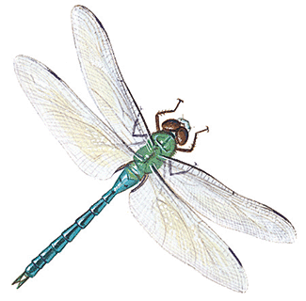
- Dragonflies are ________. They have a ____________ with six _______and four __________, an ____________, and a __________with _________ and ____________.
- Dragonflies are omnivores.
- Dragonflies have a thin _____________ for protection.
head | exoskeleton | abdomen | legs
mouth | INSECTS | thorax | EYES

