AK6 18/3/2020

TAKE A LOOK TO THE PICTURE AND COMPLETE THE GAPS USING PAST SIMPLE:
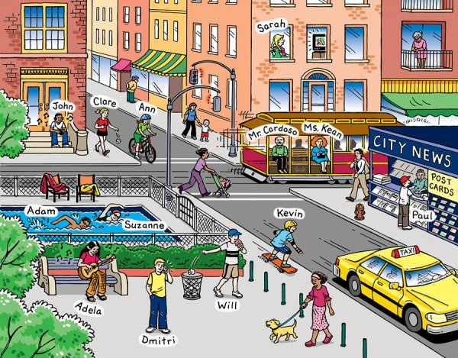

Put the verbs in the past simple tense because this is what they did yesterday.
It _ _ _ _ _ (is) a nice day in town yesterday. Adela _ _ _ _ (sit) on a bench and _ _ _ _ _ (play) her guitar. Adam and Suzanne _ _ _ _ _ (swim) twenty lengths in the outdoor pool. Paul _ _ _ _ _ (buy) a postcard to send to his friend in England. John __ _ _ _ (listen) to music. Kevin _ _ _ _ _ (go) skateboarding. Mr Cardoso and Ms Kean _ _ _ _ _ (take) the tram. Ann _ _ _ _ _ (ride) her bike. A lady dressed in pink _ _ _ _ _ (walk) her dog. Sarah _ _ _ _ _ (watch) TV. Will _ _ _ _ _ (eat) a cake and _ _ _ _ _ (put) the wrapper in the bin. Dmitri _ _ _ _ _ (phone) his friend and he _ _ _ _ _ (ask) him to come and pick him up. The old lady
_ _ _ _ _ (stand) on her balcony and she _ _ _ _ _ (watch) everyone.
_ _ _ _

