Watch the videos and answer the questions:

A) ECOSYSTEMS VIDEO:
1) An ecosystem is made up of…
2) The living parts in an ecosystem are…
3) The non-living parts in an ecosystem are…
4) There are two types of ecosystems:
5) Write 5 types of land ecosystems:

B) ECOLOGICAL RELATIONSHIPS: WATCH THE FIRST 4.15 MINUTES OF THE VIDEO, IN WHICH YOU CAN FIND 6 QUESTIONS. ANSWER THEM HERE:
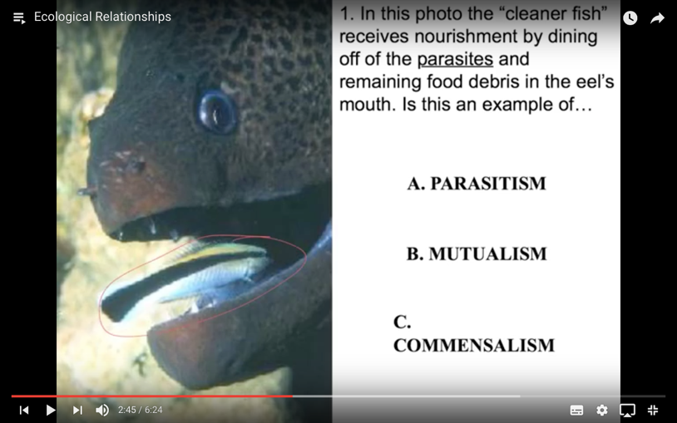
1)

ANSWER:

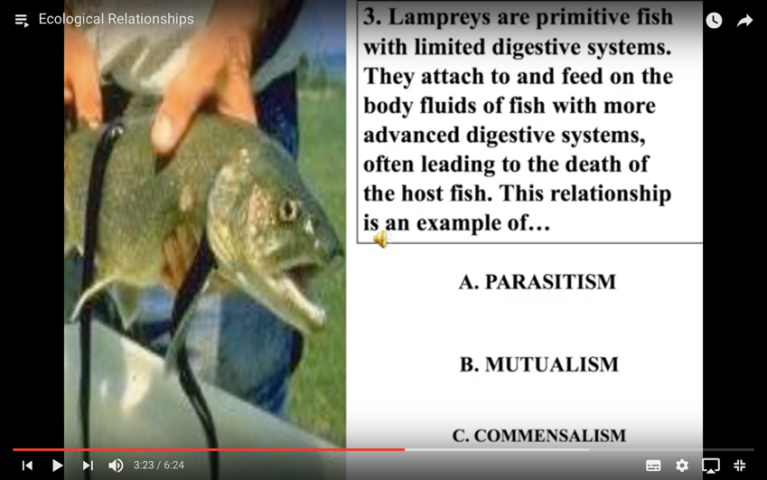
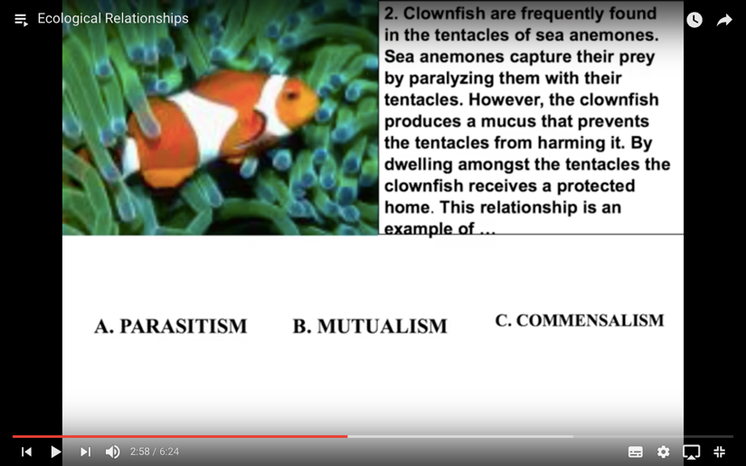
2)
ANSWER:

3)
ANSWER:

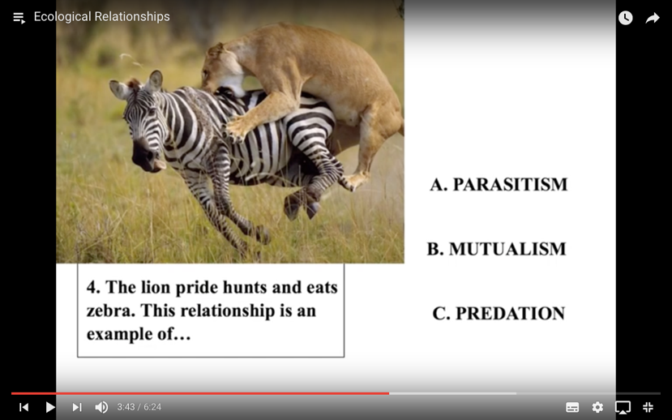
4)
ANSWER:

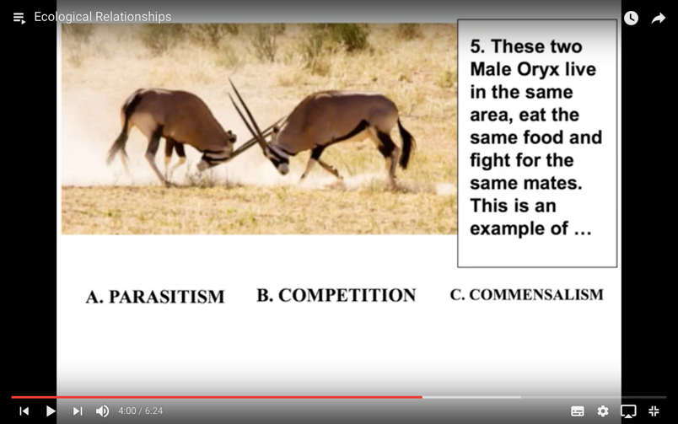
5)
ANSWER:

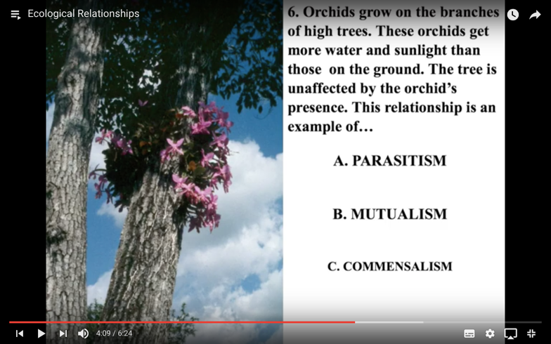
6)
ANSWER:

