English 4º PRIMARIA
TRABAJO DEL TEMA 4. ENDANGERED ANIMALS.
Name: ______________________________________________ Date: 17th March 2020
- Look and write. (Mira y escribe)
panda – iguana – tortoise – bee – turtle – dolphin – otter – rhino – hedgehog – gorilla – tiger - whale

- 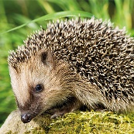 7. 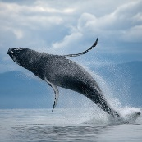
- 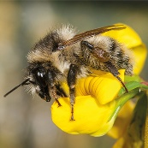 8. 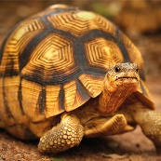
- 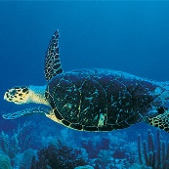 9. 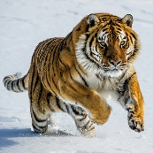
- 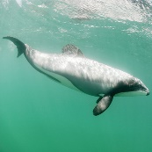 10. 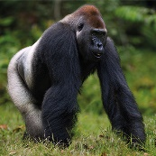
- 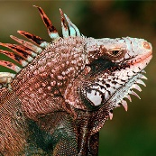 11. 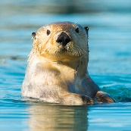
- 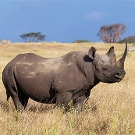 12. 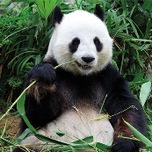
- Read and learn. (Lee y aprende)
GRAMMAR FOCUS
- There are some →
- There aren’t any → 0
- There aren’t many → not lots

- Order the words. (ordena las palabras)
- some / There / the / in / garden. / hedgehogs / are
___________________________________________________________________
- whales / in / There / any / river. / the / aren’t
___________________________________________________________________
- bees / the / aren’t / world. / There / in many
___________________________________________________________________
- any / garden? / there / Are / in / bees / the
___________________________________________________________________
- are. / there / Yes, → __________________________________________________
- there / aren’t. / No, → ________________________________________________
- Look at the map, read and write many or any. (Mira el mapa, lee y escribe many o any)
- There aren’t ________ tigers in Africa.
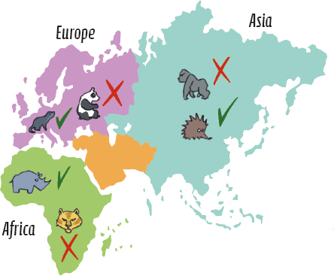
- There aren’t ________ gorillas in Asia.
- There aren’t ________ otters in Europe.
- There aren’t ________ hedgehogs in Asia.
- There aren’t ________ pandas in Europe.
- There aren’t ________ rhinos in Africa.

- Look at the pictures and write. (Mira los dibujos y escribe)
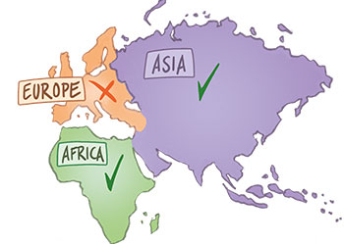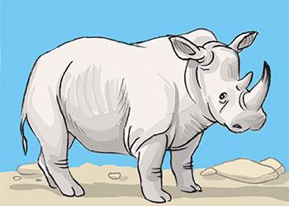
Rhinos are endangered animals. There __________ in the world.

There aren’t ________ in Europe.

There aren’t ___________ in Africa or Asia.

- Look and write. ( Mira y escribe)
field – ocean – savannah – desert – rocks – forest – river - island

- 5. 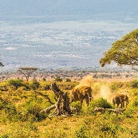
- 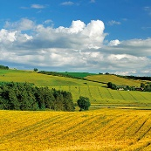 6.
- 7.
- 8. 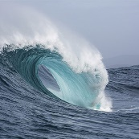
- Watch the video and answer the questions.( Mira el video y responde)
- What do hedgehogs eat? ______________________________________________.
- What do hedgehogs drink? ____________________________________________.
- Where do hedgehogs live? _____________________________________________.
- Are there any hedgehogs in Britain? _____________________________________.

