ENGLISH 5º PRIMARIA
REVIEW UNIT 4. AROUND MY TOWN
Name: ______________________________________________ Date: 17th March 2020
- Look and write. (Mira y escribe)
art gallery – beach – castle – football stadium – fountain – hotel – department store - ice rink – market – shopping centre – square – statue – tourist office – town hall

- 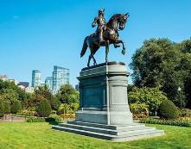 ____________ 8. 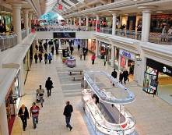 ____________
- 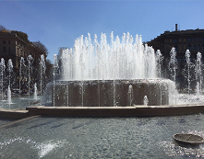____________ 9. 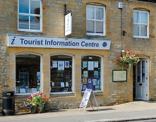 ____________
- 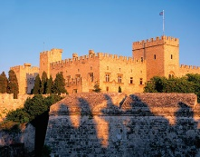 ____________ 10. 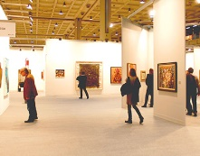 ____________
- 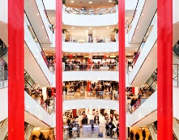 ____________ 11. 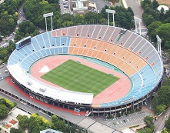 ____________
- 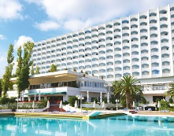 ____________ 12. 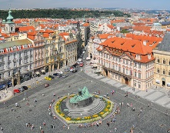 ____________
- 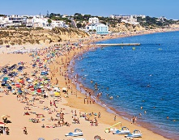 ____________ 13. 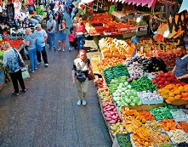 ____________
- 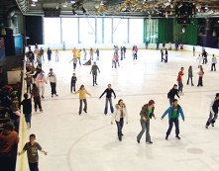 ____________ 14. 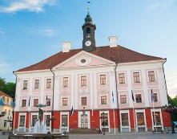 ____________

- Read and learn. (Lee y aprende)
PAST SIMPLE OF BE
was
- I / He / She / It at the market on Tuesday.
wasn’t

were
- You / we / They at the shopping centre yesterday.
weren’t

PAST SIMPLE OF BE: QUESTIONS 1

was I / he / she / it
- Where last week?
were you / we / they

- I / He / She / It was at the square.

- You / We / They were at the football stadium.

PAST SIMPLE OF BE: QUESTIONS 2
Was I / he / she / it
- at the town hall yesterday?
Were you / we / they
Yes, was.
- I / he / she / it
No, wasn’t.

Yes, were.
- you / we / they
No, weren’t.

PAST SIMPLE OF BE: THERE WAS /WASN’T / THERE WERE / WEREN’T

was
- There a castle.
wasn’t

were statues.
- There
weren’t any cafés.

Yes, there was / were
- Was there a playground?
- Were there any cafés? No, there wasn’t / weren’t

- Write affirmative sentences in the past simple of BE.
- Sally ______________________ tired yesterday afternoon.
- It _________________________ cold yesterday.
- I _________________________ in Dublin in 2008
- Margaret and William _______________ in a vegetarian restaurant.
- There ______________ blue flowers at the garden yesterday
- There _____________ a school bag at the corridor.
- He ________________________ at the zoo the last weekend.
- You _______________________ born in July.
- We _______________________ friends.
- Write negative sentences in the past simple of BE.
- My cousin ________________ at school.
- There _____________ a car on the bed.
- We _______________ at the beach the last Sunday
- There ____________ pencils under the desk.
- I ___________________ tall.
- Sandra________________ hungry yesterday morning.
- Michael and Harry ___________ born in 2001.
- You _________________ thirsty.
- It ___________________ raining yesterday.
- Write interrogative sentences in the past simple of BE and answer them.
- She / at the swimming pool.
_________________________________? No, ________________________
- Alfred and Jamie / shy.
________________________________? Yes, _________________________
- He / at the funfair.
________________________________? Yes, _________________________
- They / eleven years old.
________________________________? No, _________________________

- Write the questions and answers in the past simple of BE.
- What time / they / at the restaurant → at half past seven
_______________________________? _____________________________.
- Where / she → city hall
_______________________________? _____________________________.
- How old / he → eight
_______________________________? ______________________________.
- Why / he / at home → ill
________________________________? _____________________________.
- Read and number.
- 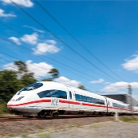 5. 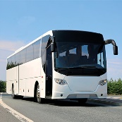

underground ____
lorry ____
cable car ____
motorbike ____
high-speed train ____
coach ____
ferry ____
rickshaw ____
- 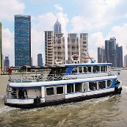 6. 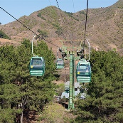
- 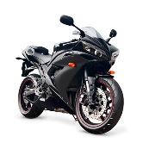 7. 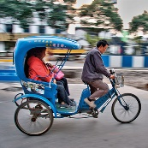
- 8. 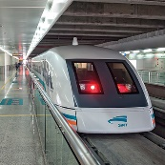

- Watch the vlogs and complete the sentences with was, wasn’t, were, weren’t.
- The “queen” _________ a statue.
- The swings ___________ on the right of Park Road.
- Charlie ______________ at the shop.
- The treasure __________ at the café.
- The milkshakes at the café __________ the prizes.
- At the end, Charlie and Sophie ______ asleep.

