English 2º PRIMARIA
TRABAJO DEL TEMA 4. HOMES
Name: _________________________________________________________________
- Read and write. (Lee y escribe)
living room – kitchen – bathroom – garage – hall – attic – dining room - bedroom

- 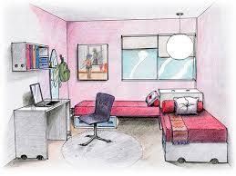 5. 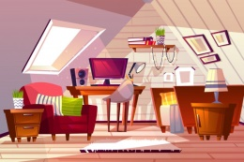
- 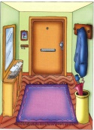 6. 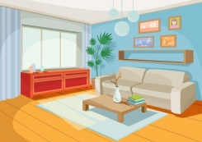
- 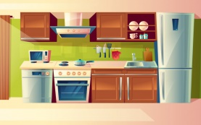 7. 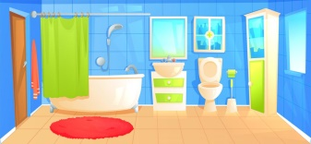
- 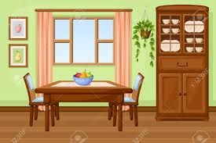 8. 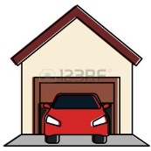
- Look and write.(Mira y escribe)
- There’s ________________ on the ground floor.
- 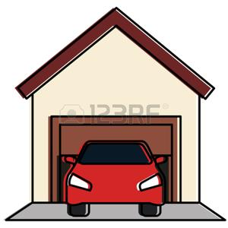 2.

- 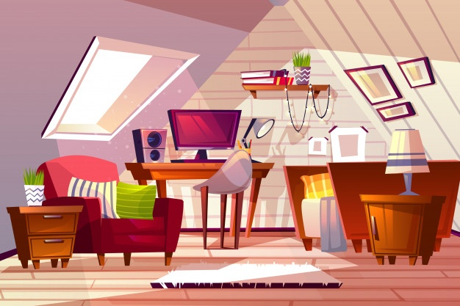 4.

- 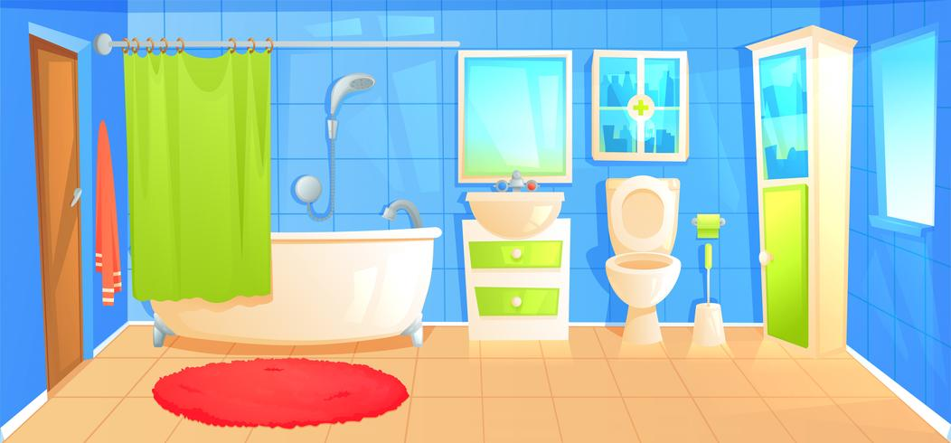6. 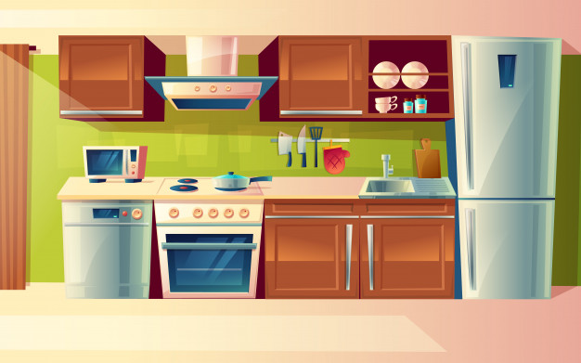
- There isn’t _____________ on the first floor.
- _______________________ on the second floor.
- _______________________ on the third floor.
- _______________________ on the fourth floor.
- _______________________ on the fifth floor.

- Read and repeat. (Lee y repite) Entre paréntesis puedes leerlo como se dice.
- 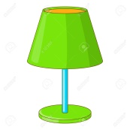lamp (lamp) 2. 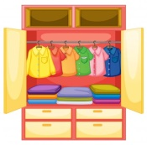wardrobe (guordroub)
3.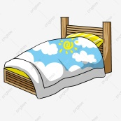 bed (bed) 4. 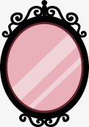 mirror (miror)
5. 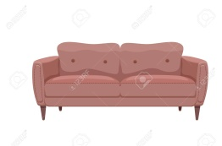sofa (soufa) 6. 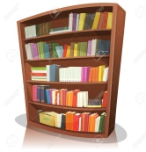 bookcase (bukkeis)
4. Read and write. (Lee y escribe)
bookcase – sofa – lamp – wardrobe – mirror – bed

- 4.
- 5.
- 6.

