English 3º PRIMARIA
TRABAJO DEL TEMA 4. FOOD
Name: _________________________________________________________________
- Read and write. (Lee y escribe)
beans – potatoes – green salad – fish and chips – tomato soup – rice – carrots – chicken – peas - fruit salad – bread - fried eggs

- 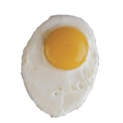 7. 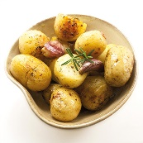
- 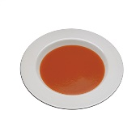 8. 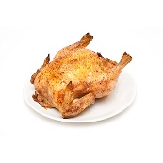
- 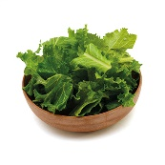 9. 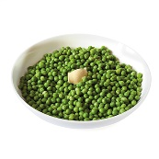
- 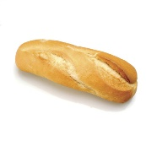 10. 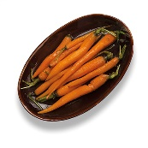
- 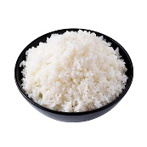 11. 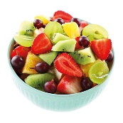
- 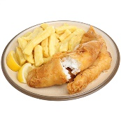 12. 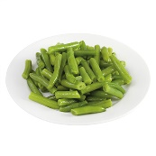

- Read and number. (Lee y numera)
- 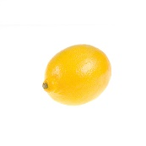 2. 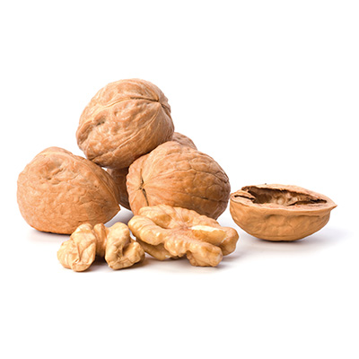 3. 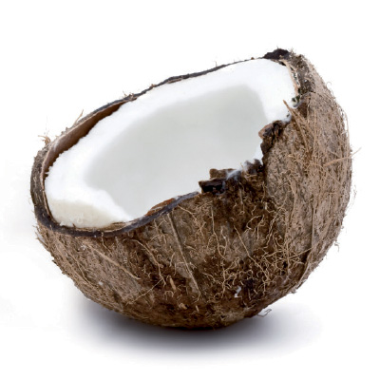 4. 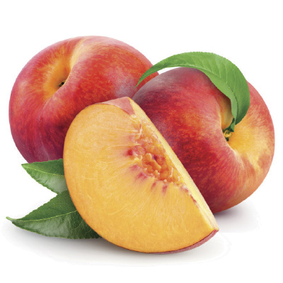

5. 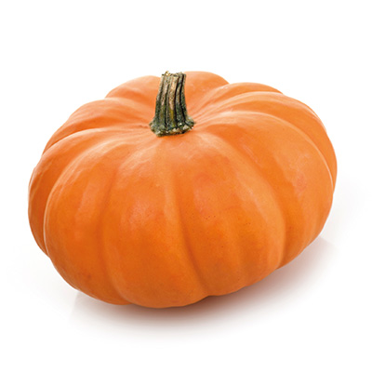 6. 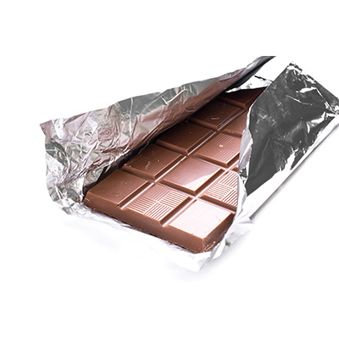 7. 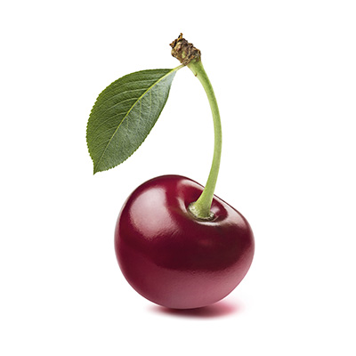8. 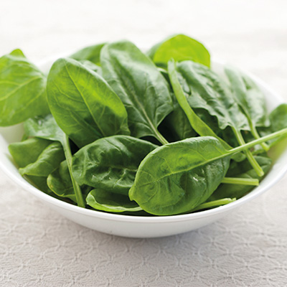

Spinach cake ___
Pumpkin cake ___
Chocolate cake ___
Coconut cake ___
Cherry cake ___ Peach cake ___
Lemon cake ___
Walnuts cake ___
- Order the sentences.(Ordena las frases)
- chicken? / she / Does / like → _______________________________________________
- she / Yes, does. → ________________________________________________________
- tomato soup? / like / he / Does → ___________________________________________
- doesn’t. / No, / he → ______________________________________________________
- likes / doesn’t / chocolate / like strawberries. / Super Dad / he / but
_______________________________________________________________________
- doesn’t / she / like / cake. / likes / but / apples / Super Mum
_______________________________________________________________________
- Read. Answer the questions. (Lee. Responde las preguntas)
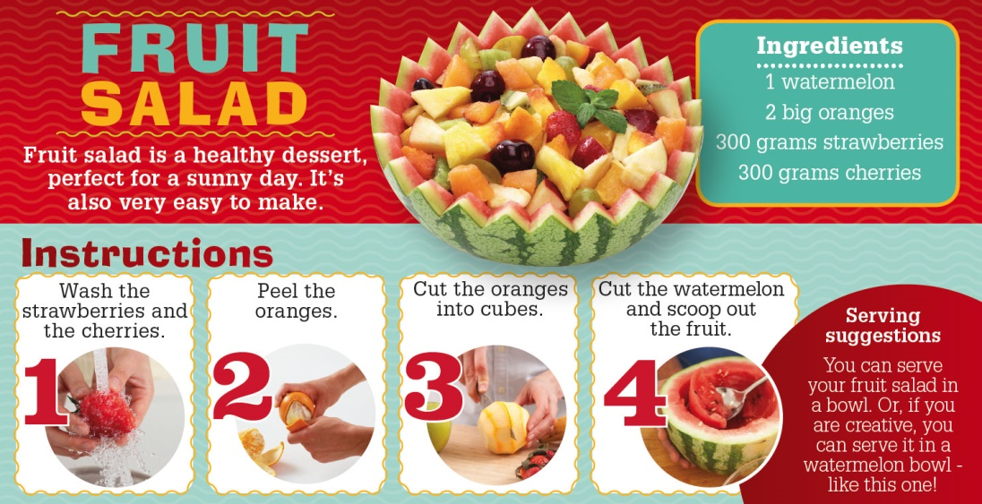

- Is fruit salad difficult to make? ______________________________________________
- Can you served the salad in a bowl? __________________________________________
- How many oranges do you need? ____________________________________________
- Do you think this is a good recipe? Why? ______________________________________
- Read and circle the correct word. (Lee y rodea la palabra correcta)
Girl: I don’t like / likes pasta.
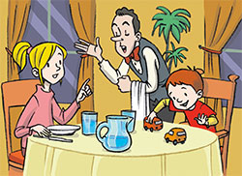
Waiter: Do /Does you like soup? Girl: Yes, I do. I love / loves soup. Waiter: And do / does your brother like soup? Girl: Yes, he does. He love / loves soup, too. Waiter: Does he like / likes pea soup? Girl: No, he doesn’t. He doesn’t / does like green vegetables.
- Look and write. (Mira y escribe)
- 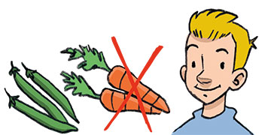(Ben) 2. 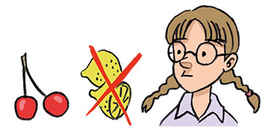(Susie)

3. 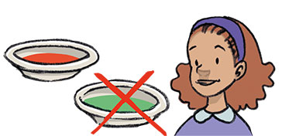(Jess) 4. 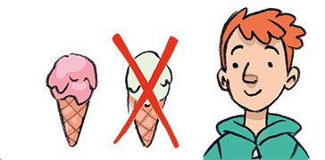(Fred)

- Does Ben like vegetables?
He likes beans, but he doesn’t like carrots.
- _____________________________________________ fruit?
________________________________________________________________.
- _____________________________________________ soup?
________________________________________________________________.
- _____________________________________________ ice cream?
________________________________________________________________.

