**INGLÉS 1º PRIMARIA**

**Repaso tema 4. Food**

1. **Read and write. (Lee y escribe)**

**tuna – chicken – tomatoes – cheese – pineapple – olives – peppers – meatballs**

1. 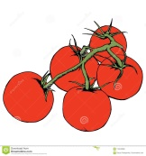 **5.** 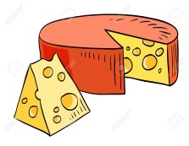
2. 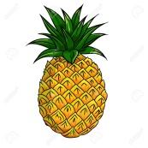 **6.** 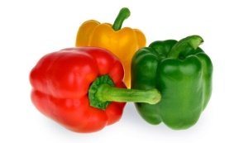
3. 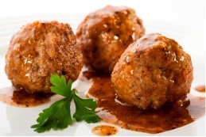 **7.** 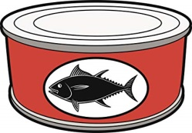
4. 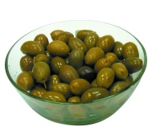 **8.** 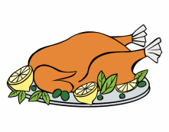
5. **Draw food and write. (Dibuja una comida y escribe)**





I like _____________________________. I don’t like ______________________.

1. **Look and write. (Mira y escribe)**
2. 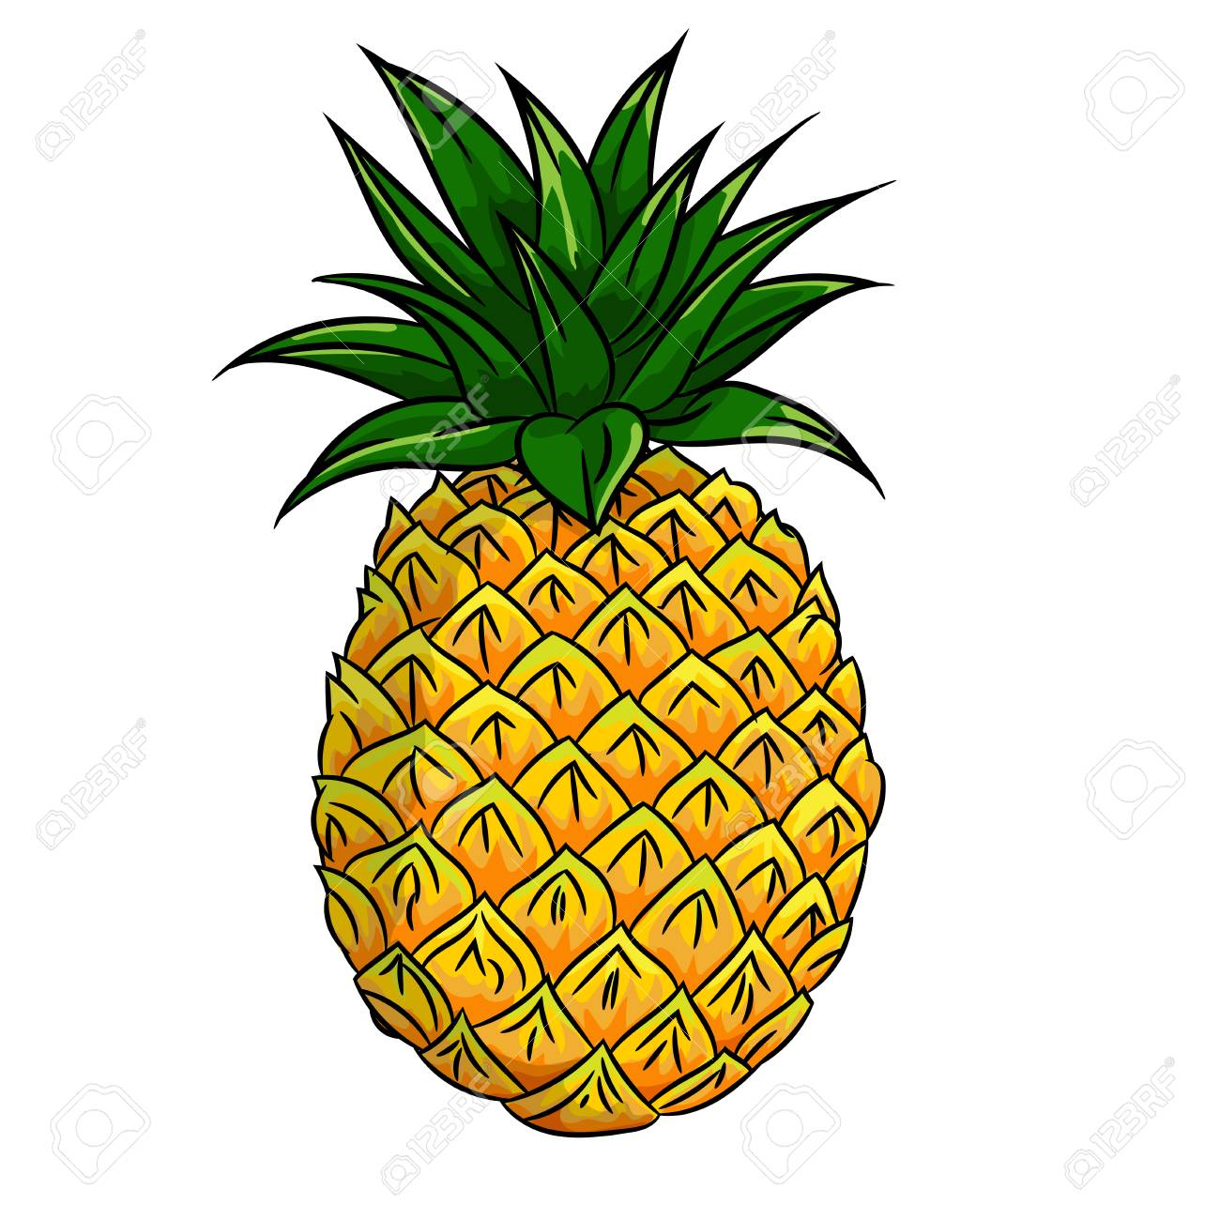 2. 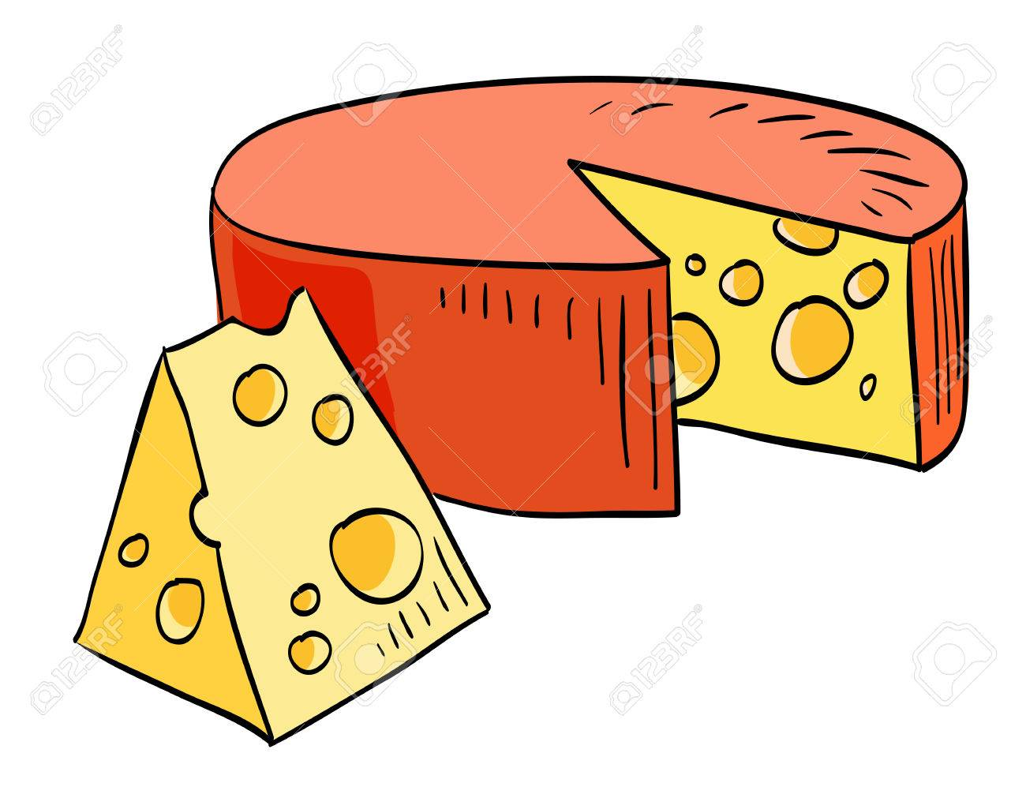
3. 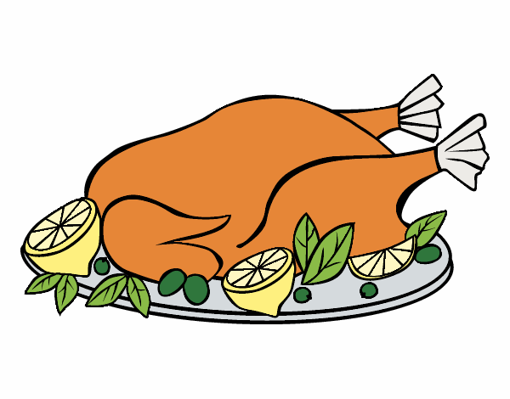 4.  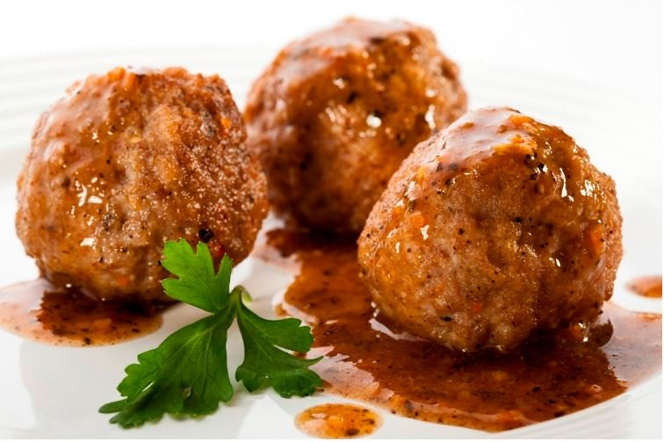
4. 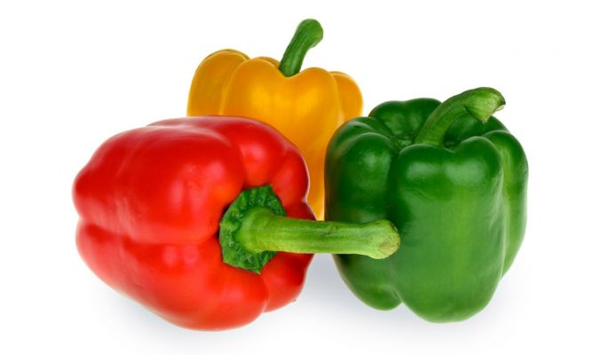6. 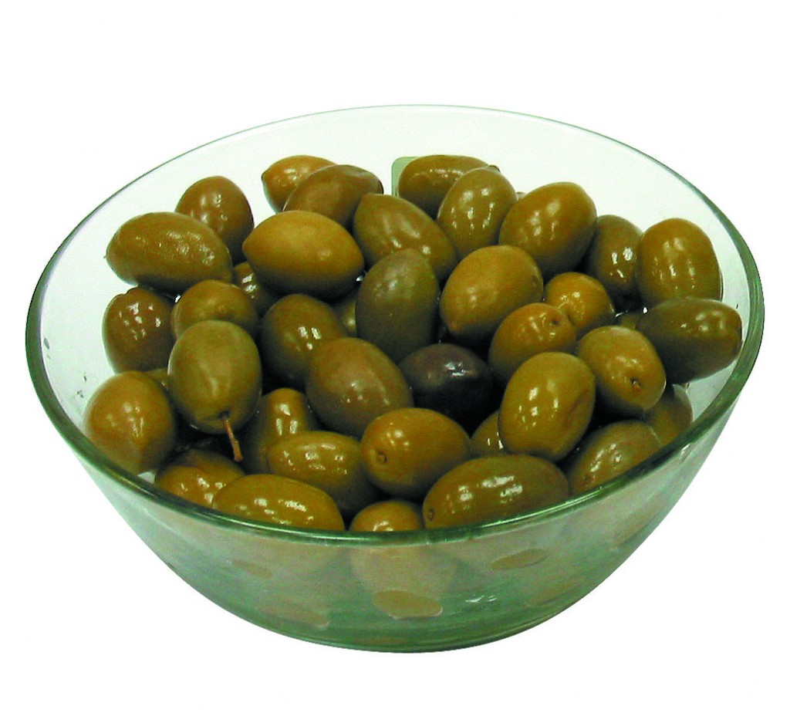
5. I ________________ pineapple.
6. I ________________________ cheese.
7. ___ _________________ ____________
8. ___ __________________ ___________
9. _________________________________
10. _________________________________
11. **Read and number. (Lee y numera)**
12.  **mint ice cream _____**
13. 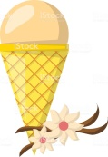 **strawberry ice cream _____**
14.  **chocolate ice cream _____**
15.  **vanilla ice cream ______**
16.  **blackberry ice cream _____**